doh logo 1

**Interim Fish Advisory for Fuel Pier and Marina Area**

**at the Marine Corps Base in Kaneohe, Hawaii**

The Hawaii State Department of Health is advising the public not to eat fish and shellfish caught in the Kaneohe Marine Corps Base Fuel Pier and Marina Area, a military protected area within Kaneohe Bay, Hawaii. Fish caught in this area may contain harmful chemicals. High risk groups such as pregnant women, nursing mothers, women who are planning a pregnancy and children are especially sensitive to these chemicals.

**Avoid eating fish from this area until testing is complete.**

**Preliminary testing indicates that certain fish in the Fuel Pier and Marina Area contain unsafe levels of polychlorinated biphenyls (PCBs). Eating fish and shellfish from this area could harm your health.**

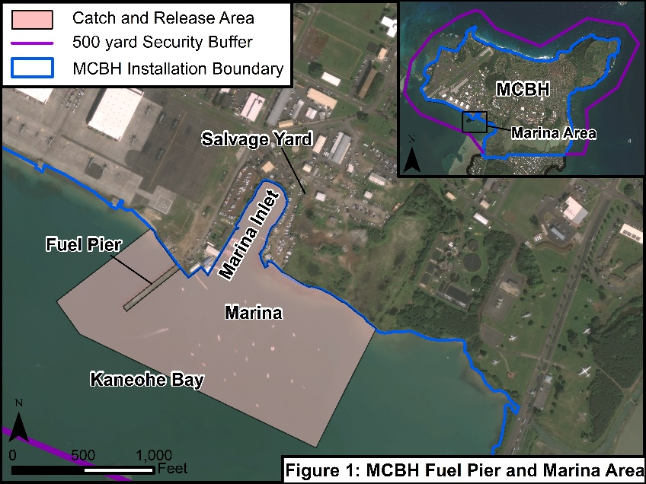

**What are PCBs?**

* PCBs are man-made chemicals banned in the United States since 1976.
* PCBs were used extensively in manufacturing transformers, capacitors and other electrical equipment
* PCBs stick to soil and sediment and remain in the environment for a long time
* Fish take in PCBs when they eat sediment or smaller fish containing PCBs.
* PCBs build up in the fat of fish and can reach levels many times higher than the level in water or sediments.

Frequently eating PCB-contaminated fish over a period of years may lead to PCBs building up in your body to levels that could affect your health.

The health effects from eating fish contaminated with PCBs depend on

* The concentration of PCBs in the fish you eat,
* How much fish you eat, and
* How long you eat it (for example, over weeks, months, or years).

Health effects also depend on your age, sex, diet, family traits, lifestyle, and overall state of health.

Eating large amounts of fish from this area for many years may put you at higher risk for cancer or other diseases.

**Studies have linked PCB exposure to these health conditions:1**

In the past, some people were exposed to very high levels of PCBs at work or from accidental poisoning.

* These people showed harmful health effects to their skin, eyes, and nerves.

Studies with animals showed that high levels of PCBs could harm the liver, digestive tract, and nerves; and could affect development, reproduction, and the immune system.

* PCBs have also been found to cause cancer in some animal studies.
* The United States Environmental Protection Agency say that PCBs probably can cause cancer in humans.

PCB levels in fish are much lower than levels that may have made people sick in the past from work or accidental poisonings. PCB levels in fish also are much lower than levels given to laboratory animals.

* Some studies suggest that low levels of PCBs, like those found in some fish, might cause small decreases in children’s’ I.Q. or affect their memory, especially if exposures occur during pregnancy.

Your risk of cancer or other health effects from eating contaminated fish or shellfish cannot be predicted with certainty.

[1]

**Some groups are at higher risk for health effects from PCBs:**

* Pregnant women,
* Nursing mothers,
* Women who are planning a pregnancy, and
* Children

**It is unlikely that you will show obvious signs of harm from PCBs in fish and shellfish.**

* At the PCB levels measured by the Navy in whole goatfish from Fuel Pier and Marina Area at MCBH, we would not expect you to become ill from a single large meal or a few fish meals.
* However, frequent eating of PCB-contaminated fish over a period of months or years may lead to the buildup of PCBs that could affect your health.
* To prevent PCBs from causing harmful effects, DOH advises you to stop eating fish from the Fuel Pier and Marina Area at MCBH until further testing is completed.
* Over time, PCBs and other contaminants can slowly clear from your body and lessen your risk.
* To avoid any risk to your health, **follow the DOH fish advisory**.

**You can also protect your health by maintaining a healthy lifestyle.**

* Get regular exercise;
* Eat a balanced and nutritious diet including fish from uncontaminated waters;
* Moderate your alcohol intake if you drink; if you smoke, try to quit;
* Get regular medical checkups for yourself and your family; and
* Minimize stress as much as possible.

**This interim advisory is based on limited sampling of whole goatfish by the U.S. Navy in the Fuel Pier and Marina Area. More testing will be done.**

* The fish were sampled to determine if PCBs from the Salvage Yard are concentrating in recreational fish.
* The testing revealed levels of PCBs that were higher than acceptable.
* Further testing will determine if the fillets versus the whole fish contain unsafe levels of PCBs.

**Contacts:**

**Hazard Evaluation Emergency Response Office 808-586-4249**

For more information about DOH oversight of cleanup activities at the Salvage Yard, contact Beryl Ekimoto, beryl.ekimoto@doh.hawaii.gov. For health effects, contact Dr. Barbara Brooks, [barbara.brooks@doh.hawaii.gov](mailto:barbara.brooks@doh.hawaii.gov)

**Marine Corps Base Hawaii**  **808-257-1365**

ATTN: Public Affairs Office

Strategic Plans and Engagement

EMAIL kbaz_pao@usmc.mil

1. *Information from California Office of Environmental Health Hazard Assessment* [*https://oehha.ca.gov/fish/pcbs-fish-caught-california*](https://oehha.ca.gov/fish/pcbs-fish-caught-california)*)*