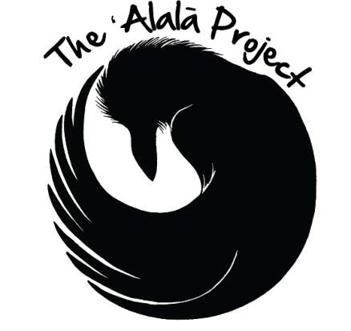

` **ELEVEN ALALA NOW THRIVING IN HAWAII ISLAND NATURAL AREA RESERVE**

**Video News Release:**

<https://vimeo.com/252588023>

**Photographs: (Courtesy: San Diego Zoo Global)**

<https://www.dropbox.com/sh/86z5ilimwh0x0ha/AACUBZZrFmamiTnSnJUrJ2ana?dl=0>

**Video clips and interviews: (Courtesy: Hawai’i DLNR)**

<https://vimeo.com/252622169>

:00-2:27 Various shots of Alala

2:27-3:40 Joshua Pang-Ching SOT (observations of birds in the wild)

Research Coordinator, Hawaii Endangered Bird Conservation Program

4:02-4:42 Joshua Pang-Ching SOT (impressions of how the birds are doing?)

4:42-5:36 Joshua Pang-Ching SOT (human vs. natural feeding observations)

5:36-9:29 Various Shots of Alala

9:29-9:52 Dr. Alison Greggor SOT (monitoring team function and how birds are doing?)

Post-Doctoral Research Associate, San Diego Zoo Global

9:52-10:29 Dr. Alison Greggor SOT (discusses predator vs. prey interactions)

10:30-11:03 Jackie Gaudioso-Levita SOT (bird’s adjustment and future monitoring)

Project Coordinator, The Alala Project

11:03-11:54 Jackie Gaudioso-Levita SOT (current monitoring effort)

11:55-12:30 Jackie Gaudioso-Levita SOT (lessons learned from 2016 release)

12:30-14:00 Radio tracking/monitoring sequence