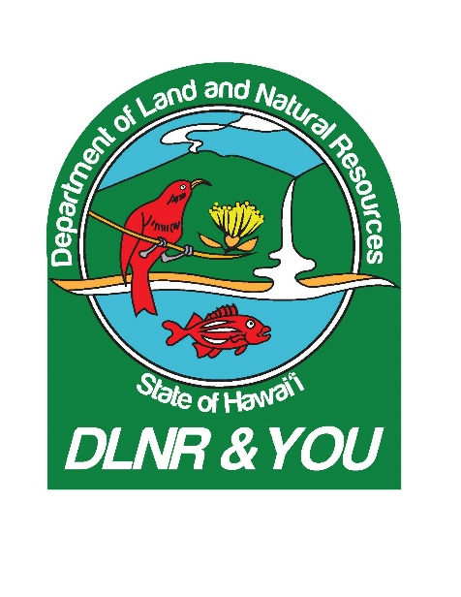

**KA’ENA POINT STATE PARK RULES OF THE ROAD**

Video Shot Sheet, April 10, 2018

:00 Various trucking shots from ATV (Please note that this type of unlicensed is not permitted at Kaena Point but is used by State Parks and DOFAW for official government work)

1:27 Jamie Raduenzel SOT-Shows sediment flowing down a gully toward the ocean

1:44 Severely eroded slope

2:01 Trucking shots along designated coastal road

2:20 Jamie Raduenzel SOT-talks about how even good four-wheel-drive vehicles are slipping downhill in muddy conditions and how these tracks make it confusing for others to identify designated routes.

3:01 More trucking shots

5:00 Detour signs around trouble spot

5:15 Jamie Rauenzel SOT-speaking near a large mud pond which is one of the primary problem areas at the park.

6:06 Jamie Rauenzel SOT-talks about how she tries to educate recent Hawaii arrivals who don’t realize that we don’t have designated off-roading areas here.

6:52 Jamie Rauenzel SOT-speaks about regular, permitted park users who are supportive of temporary road closures.

8:12 Static shots of trouble spot

8:30 More trucking shots

8:51 Designated road signage

9:00 More trucking

9:40 Jamie Rauenzel SOT-discusses how water from road pond flows downhill and into the ocean

10:42 ATV and large puddle (Please see note about this vehicle usage at the beginning)

11:33 Water flowing

12:20 Static of washed out road

12:53 Trucking shots

13:48 Sequence of road closed signs