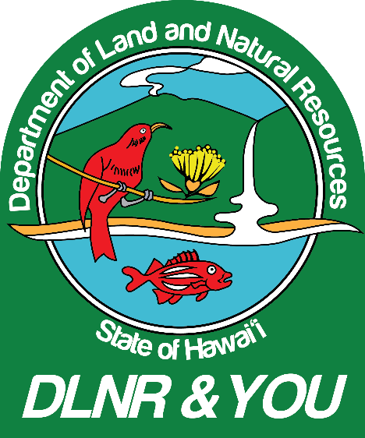

**NURSERY-GROWN PYRAMIDS OF NATIVE CORALS NOW RESTORING NATURAL REEFS**

Video Shot Sheet and Transcriptions

May 1, 2018

:00-4:47 Corals at Anuenue Coral Restoration Nursery and moving pyramids for transportation

4:47-10:49 Coral pyramids arriving at Sand Island State Park and underwater footage

of out planting

10:49-11:28 David Gulko SOTS

“So, since this hasn’t really been done before, we needed a place where we could easily monitor the status of these outplants, look for any problems that may occur, check their growth rates. Remember that we’re fast-growing them in the coral nursery, but once we put them back into the wild they go back to the same growth rates that every coral in Hawaii is growing at, which on average is about one centimeter a year, which is one of the slowest growth rates of coral anywhere in the world. And those slow growth rates make it very hard for reefs to recover naturally from human impacts so that’s why we’re giving them a little bit of help.”

11:33-11:42

It’s an extremely slow process here in Hawaii, but we have started to document that growth rate on the modules out on the natural substrate, but it’s very slow.”

11:53-12:12

“We also put out some that were incomplete and fractured into different shapes. From the results of those studies, we we’re able to determine the best size and shape from these modules, given the high wave energy that tends to occur on our fringing reefs here and given the natural conditions that we tend to have on our near shore reefs.”

12:21-13:09

“We only grow natural corals, native corals at the coral nursery for out planting and we try to replicate the natural assemblage of species that occurs at those sites. So, we’re not going to introduce species into areas that don’t naturally occur there. And we will try to recover them to back what it used to be, 30-40-50-100 years ago to the best of our ability. The numbers that we put in at any given site will be based on the topography and the natural assemblages that occur there. And it will also be factored in relative to the support we have for growing those corals to place out and where the highest need is and where the highest likelihood is of those corals growing and thriving.”

13:21-15:05

“When we transplant corals out into natural reef environments we have to acclimate them because in the coral nursery it’s basically like being in a five-star hotel. They’re given all the best foods, the best lighting, the best water conditions. They’re given lots of tender loving care and together this allows these corals to grow at a fast rate. Once we put them back into natural waters, what ends up happening is that growth rate slows down and we have to slowly acclimate them back to the not pristine water we have surrounding our shallow water reef environments. The wave action that occurs, the intermittent light, the presence of sediment and other things in the water, so we slowly acclimate them over a period of about a month to the prevailing conditions at the outplant site and then we transport them to the site in very large containers with lots of sea water. And we carry them out on suspended platforms that we can swim out to the site, slowly lower them to the bottom and then we mix up a type of two-part epoxy that has been shown here in Hawaii to not negatively affect the corals in any discernible degree. We know this epoxy will not affect their reproduction which is one of our chief concerns. And that by the way is one of the reasons we’re putting out these larger corals, because at these larger sizes they are reproductively active. We mix up the epoxy underwater, we pat it down and we carefully place the module onto that epoxy after the area has been scrubbed clean of fouling material like fuzzy algae cyno-bacteria, etc. And then we try to place the corals so they’re not so close together that they’ll cause problems with each other and they have some space to grow over time.”

15:16-15:34

“We took a slow approach because we wanted to work out all the bugs before we started out planting corals into natural reef environments; especially protected reef environments. With these outplants that we’re doing here and the status that the nursery is at we’re ready to start scaling up into full production shortly.”

15:42-16:39

“In most places in the world where there’s coral reefs, corals grow a lot, lot faster than they do here and they have species that grow extremely fast that we don’t have here in Hawaii. So, the economics is such that there are other ways of growing branching species that are already fast growing and a lot cheaper than what we’re doing here. Unfortunately, that doesn’t happen here in Hawaii. We have large, boulder like massive corals that are very slow growing, so these techniques have been developed here specifically for those types of corals and our types of reefs. Is it transferable? Yes. Are there other places starting to look into it? Yes. There’s two land-based nurseries in Florida right now that are experimenting with techniques similar to what we’ve initiated here and there’s interest in others parts of the world in what we’re doing here. Australia, Africa and some parts of southeast Asia are also looking into this.”

16:47-17:14

“As we put out these modules, what we expect to see is changes in fish biomass, fish numbers, other invertebrates. It’s the basis of a healthy reef. It’s like having trees in a forest. Once you have trees in the forest it provides shelter and shade and all the conditions, food and nutrients that can support a wide variety of animals, birds, and insects. Well in the ocean it’s the fish, invertebrates, and plankton and that’s what we’re hoping to do by placing these large coral colonies.”

17:20-17:39

“We’re hoping once we get up to full production at the coral nursery, once we upgrade the nursery with some newer tanks and newer systems, we’re hoping to produce about 220 large, that’s 42 cm pyramid modules a year for out planting.”