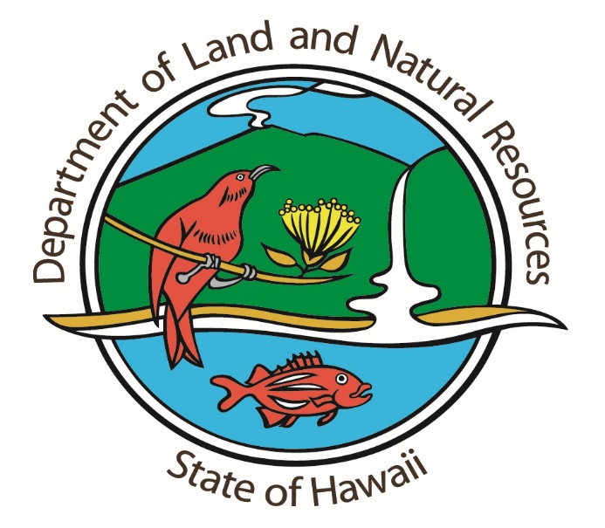

**RAPID OHIA DEATH ON KAUAI**

**PHOTO CUT SHEET & VIDEO SHOT SHEET & TRANSCRIPTIONS**

**May 11, 2018**

**PHOTO ALBUM:**

<https://www.dropbox.com/sh/mq70cw6a28ntdvv/AADuifNH5sjB19l0e0ZSRz7ba?dl=0>

Images 1601-1610 Helicopter loading and crew for sketch mapping of affected area

Images 1613-1651 Helicopter sketch surveying and aerials of Moloa‘a Forest Reserve & trees

Images 1652-1657 Rapid response team members hiking into the forest reserve

Images 1658-1684 Rapid response team in the forest reserve for sampling & training (Dr. Marc Hughes)

Images 1687-1690 Dr. Wade Heller

Images 1691-1694 Infected trees

Images 1695-1698 Rotorod pollen and airborne particulate sampler

**HD VIDEO:**

<https://vimeo.com/269082425>

:00-7:35 Rapid response team, demonstrations and training

7:39 Dr. Lisa Keith SOT

“When we commonly talk about Rapid Ohia Death, really that was a popular coined term to seeing visible symptoms occurring very rapidly and was really the stat of public sampling. I saw my free and it looked alive and it seemed to in a couple of weeks to a month to rapidly die. So we started calling what was going on Rapid Ohia Death.”

“Since finding cyratocystis on the Big Island we determined that two new species of cyratocystis are causing Rapid Ohia Death, but scientifically they are very different pathogens. So the more aggressive pathogen that is associated with all the widespread mortality seen on the Big Island is cyratocystis lukuohia. It’s a very widespread, aggressive pathogen on the Big Island. Once it gets in through a wound it rapidly colonizes the tree, so the fungus starts growing throughout the entire tree very quickly and scientifically it’s called a vascular whilt. So it is blocking the water and it results in what looks like a very quick drought death of the tree.”

“What we found on Kauai is the second fungus called cyratocystis huliohia. It is a very different pathogen. Even the genetics of these fungi are different. The first one described lukuohia is considered a very harsh tree killer. What was formerly species B, huliohia we actually suspect we found because we started looking at this widespread mortality of ohia on the Big Island. So this is what is known as a canker pathogen. In both cases you don’t see anything on the outside of the tree.”

“It is possible that huliohia has been around for a very long time, killing a tree or two that really didn’t draw alarm to what was happening in the forest or on a person’s property. There are other pathogens that can kill ohia; harsh weather conditions, wounding events that don’t allow the tree to thrive well. So what we’re now looking at on Kauai is cyratocystis huliohia. It doesn’t appear to be widespread. We’re still trying to get a better understanding of potentially how many trees have been a ffected by the cyratocystis. Right now it’s just a couple. Of course we don’t want to see cyratocystis in any case, but I feel far less of an alarm than finding lukuohia.”

“We don’t have a good understanding of huliohia. Is it throughout the state and we just haven’t found it? Sampling because of lukohia on the Big Island, now there’s statewide sampling and now we’re looking specifically for dead trees and get samples from them. So that’s a great question, did we stumble upon it here just because now people are looking?”

“Pretty incredible, in a matter of days state, federal, university people coming together having a training session, learning from each other on how best to see what types of symptoms you’re looking for in samples to get to be able to send to the lab to confirm trees that have dies because of cyratocystis. The rapid response team was definitely on it.”

12:08 More training and field demonstrations

14:05 Infected trees

15:30 Aerial sketch mapping of Moloa‘a Forest Reserve

23:12 Healthy ohia trees in bloom