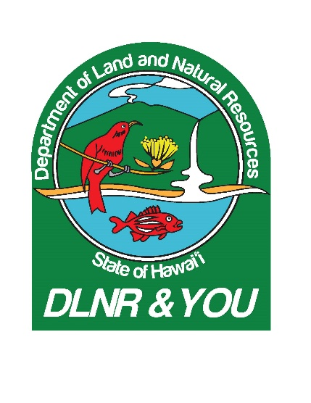

**RAPID OHIA DEATH AERIAL SURVEYS TAKE ON ADDED URGENCY**

**MAY 15, 018**

Kepana Carvalho-Oahu Invasive Species Committee, field associate, SOTS

:00-:36

“When we’re flying in the air, we actually did a ROD flight on the Big Island, so we got a good idea of what it should look like. So what we’re typically looking for is trees that have all their leaves but are dead, red, shriveled up or completely defoliated. May have all their fine branches on top, that’s indicative of the tree died quickly. If it’s missing all the fine branches, it’s been dead a while, it may or may not be Rapid Ohia Death.”

:38-:46

“It’s more real now. It’s not that distant thing anymore; like it’s on the Big Island, don’t worry about it, it’s unlikely to get here.”

:48-1:02

“It’s not that we weren’t taking it seriously before. It’s just the urgency went up a lot more. We’re going to try to sample a lot more and get up and complete everything on time, as best we can.”

1:06-1:23

“The trees we found down that side (southern Koolaus), are the easiest to access because there’s lots of trails, which also means there’s a higher likelihood of there being ohia..Rapid Ohia Death because there’s a lot of people that hike it.”

1:26-2:01

“Part of OISC’s mission statement is to stop invasive species from getting established and part of this is the decontamination. Not only does it help with the spread of ROD but other invasive species like miconia, devil weed which are some of our targeted species which we have spread because of non-decontaminated gear. Also OISC is starting to implement ROD decontamination protocols into our regular protocols. It’s not confirmed here…we just don’t want to take a chance, we’re going to do it anyway.”

2:01-7:30

Aerial surveys, southern Koolau Mountains, Oahu