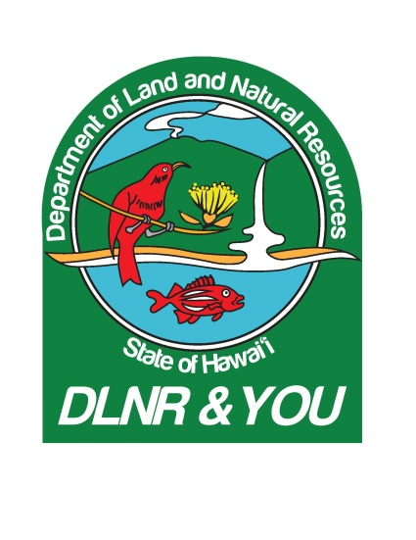

**HAWAI‘I STREAM POISONINGS**

**VIDEO SHOT SHEET & PHOTO CUT SHEET**

**May 12, 2018**

**PHOTOS:**

[**https://www.dropbox.com/sh/ta60b9ksn7w72yh/AABuzgSItlZQPllTuGgtStpca?dl=0**](https://www.dropbox.com/sh/ta60b9ksn7w72yh/AABuzgSItlZQPllTuGgtStpca?dl=0)

1362-1378 DOCARE officers and DHOA inspectors visit East Hawaii stream

1379-1385 Private land stream at ocean entrance, DOCARE & DHOA in discussion

1386-1392 Onomea Stream at Hawaii Botanical Tropical Garden

1393-1395 Polipoli Stream from bridge

**VIDEO:**

[**https://vimeo.com/269376017**](https://vimeo.com/269376017)

:00-1:40 DOCARE officers and DHOA inspectors at stream crossing

1:40-2:21 DOCARE officer Edwin Shishido driving

2:21-3:35 Another east Hawaii stream

3:35-4:17 Stream at ocean entrance on private property

4:17-6:15 DOCARE & DHOA in discussion

6:15-7:01 Onomea Stream at Hawaii Tropical Botanical Garden

7:01-9:53 SOTS-Edwin Shishido interview

11:03-11:53 SOTS-Ag inspector and garden employee discussing what happened

11:53-12:56 Tahitian prawns

12:56-14:00 SOTS-Ryan Medeiros interview

14:00-15:45 Polipoli Stream from bridge

15:45-16:00 Officer Shishido with binoculars

16:00-16:22 Prawns

16:22-16:40 Ag inspectors in stream

16:40-17:49 SOTS-Edwin Shishido interview

17:52-18:28 DOCARE officers and HDOA inspectors in stream

18:28-18:59 Bug B Gon bottles in evidence